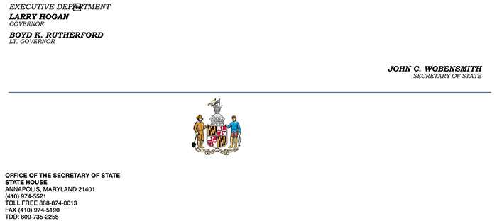

Effective March 30th, Governor Hogan ordered the in-person requirement for notarizing documents in Maryland is temporarily waived for the duration of the COVID-19 emergency, subject to guidance provided by Secretary of State John C. Wobensmith.
The Governor’s Emergency Order No. 20-03-30-03 authorizes remote notarizations and the Secretary of State’s temporary guidance issued March 30, 2020. The contents of this document are temporary guidelines that apply during the emergency waiver of the in-person requirement. All other requirements for performing notarial acts are in full force and effect. Much of this guidance is taken from a new remote notary law is currently scheduled to take effect in the State of Maryland on October 1, 2020. We will provide further information about the new law in its entirety as that date approaches. You can find a copy of the new law here: Ch. 407, SB 678 (2019 Legislative Session).
SEE EXECUTIVE ORDER
YOU MUST DO THESE THINGS TO PERFORM A REMOTE NOTARIZATION:
- You must be a current notary in good standing
- You must notify the Office of the Secretary of State of your intent to use remote notarizations
- You must identify the communications technology vendor you will use and confirm that the vendor allow you to, in real time, (1) view the remotely located individual and (2) compare for consistency the information and photos presented as identification credentials.
- For each notarial act conducted remotely, you must create and retain an audio-visual recording of the performance of the notarial act.
- For each notarial act conducted remotely, you must note on the notarial certification and in your notary log or journal that the notarial act was performed for a remotely located individual using communications technology.
- You may NOT charge more than $4 for each remote online notarial act using communication technology, which is the same fee that may be charged when performing an in person notarial act.

PLEASE NOTE THE FOLLOWING BEFORE YOU BEGIN TO PERFORM REMOTE NOTARIZATIONS:

- The Governor’s Order is a temporary waiver of the in-person requirement, which is a significant change to notarization practice in Maryland.
- The Governor’s Order requires you to use a communications technology vendor designed for the purpose of facilitating remote notarizations, as opposed to services that primarily offer video-conferencing ability. Such purpose-designed services include the ability to both see and hear and a remotely located individual (services such as Skype or Facetime do not meet the technology requirements). It is your responsibility to choose the vendor.
- For additional guidance on available technology, you may wish to review the information made available by the National Notary Association https://www.nationalnotary.org/or other professional membership associations.
- The Governor’s Order requires advance notification to be provided to the Secretary of State https://sos.state.md.us/Pages/default.aspx before performing any remote notarial acts, and you must identify the vendor. The notification form can be found at: https://sos.maryland.gov/Notary/Pages/default.aspx. You must submit the form via email to: remotenotary.sos@maryland.gov.
- Remember that you are the professional, and it is your legal responsibility to perform notarizations correctly under the law, so be certain you have read and understand all of the legal requirements under both the existing notary statute found and the provisions added by the emergency order issued by the Governor. The existing notary statute and regulations can be found in the Maryland Notary Handbook and the Governor’s Order can be found here.
- Questions may be emailed to the Secretary of State at: remotenotary.sos@maryland.gov.

Remote Notary FAQS:
Is a notary still allowed to perform in-person notarizations?
Yes, notaries public can still perform notarial acts in person during the state of emergency but should use their best judgement on whether the notarial act is considered essential and abide by social distancing, CDC and MDH guidance in the conduct of any essential notarial services. Additional guidance for performing in person notarization amid this current public health crisis can be found here: https://www.nationalnotary.org/notary-bulletin/blog/2020/03/notaries-precautions-coronavirus.

Does the Secretary of State recommend communication technology vendors?
No, the Secretary of State does not recommend or endorse a particular communication technology vendor.

Does the Office of the Secretary of State have a list of communication technology vendors?
The Secretary of State recommends you contact your local professional associations for information regarding communication technology vendors, such as the
National Notary Association https://www.nationalnotary.org/
Maryland Bankers Association: https://www.mdbankers.com/
Maryland Realtors Association: https://www.mdrealtor.org/
Maryland Land Title Association: https://www.mdlta.org/
A list of vendors, is below, the notary is responsible to determine if the vendor meets the requirements in Maryland. The list is not intended to be an all-inclusive or comprehensive list, nor is it an endorsement of any vendor, nor is it any particular order.
- DocVerify
- LenderClose
- Notarize
- NotaryCam
- Pavaso
- Safedocs
- SIGNiX
- World Wide Notary

Can I charge more than a $4 notary fee to cover my communication technology vendor costs?
No, $4 is the fee that may be charged under Maryland law.

